# Target Metrics

Overall - Accuracy: 0.7300, Precision: 0.7995, Recall: 0.7300, F1: 0.7355

Class-specific metrics:

Carbon neutral(ity) - Precision: 0.8125, Recall: 0.5200, F1: 0.6341

Emissions reduction target - Precision: 0.8000, Recall: 0.8000, F1: 0.8000

N/A - Precision: 0.0000, Recall: 0.0000, F1: 0.0000

Net zero - Precision: 0.5854, Recall: 0.9600, F1: 0.7273

No target - Precision: 1.0000, Recall: 0.6400, F1: 0.7805

# Year Metrics

Overall - Accuracy: 0.6100, Precision: 0.6171, Recall: 0.6100, F1: 0.6116

Class-specific metrics:

- Precision: 0.0000, Recall: 0.0000, F1: 0.0000

2020 - Precision: 0.0000, Recall: 0.0000, F1: 0.0000

2021 - Precision: 0.0000, Recall: 0.0000, F1: 0.0000

2022 - Precision: 0.0000, Recall: 0.0000, F1: 0.0000

2023 - Precision: 0.0000, Recall: 0.0000, F1: 0.0000

2025 - Precision: 0.5000, Recall: 0.6000, F1: 0.5455

2030 - Precision: 0.8462, Recall: 0.8800, F1: 0.8627

2031 - Precision: 0.0000, Recall: 0.0000, F1: 0.0000

2032 - Precision: 0.0000, Recall: 0.0000, F1: 0.0000

2033 - Precision: 0.0000, Recall: 0.0000, F1: 0.0000

2035 - Precision: 0.8333, Recall: 1.0000, F1: 0.9091

2040 - Precision: 1.0000, Recall: 0.8000, F1: 0.8889

2050 - Precision: 0.8846, Recall: 0.8519, F1: 0.8679

No target - Precision: 0.0000, Recall: 0.0000, F1: 0.0000

# Other Metrics

Quote Accuracy: 0.3500

Overall Accuracy: 0.4900

Valid XML Percentage: 1.0000

# Confusion Matrices

Target Confusion Matrix:

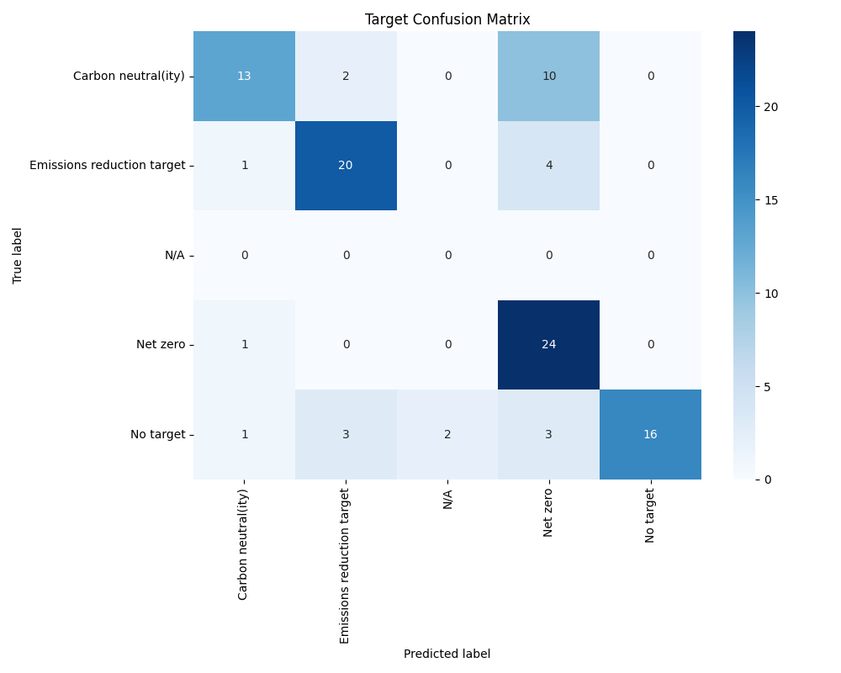

Year Confusion Matrix:

